**Lab 1 Report**

**Name: Wen Jun Student ID: 57118230**

Task 1: Manipulating Environment Variables

1. Use printenv or env command to print out the environment variables. If you are interested in some particular environment variables, such as PWD, you can use “printenv PWD”or “env | grep PWD”

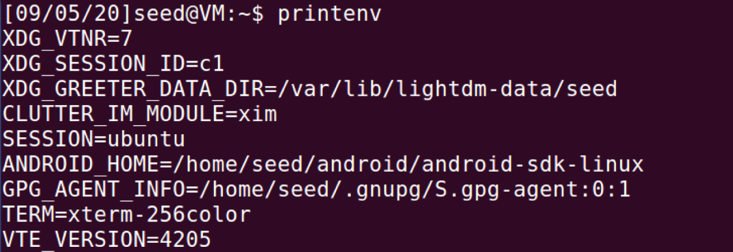

2. Use export or env command to set or unset the environment variables.

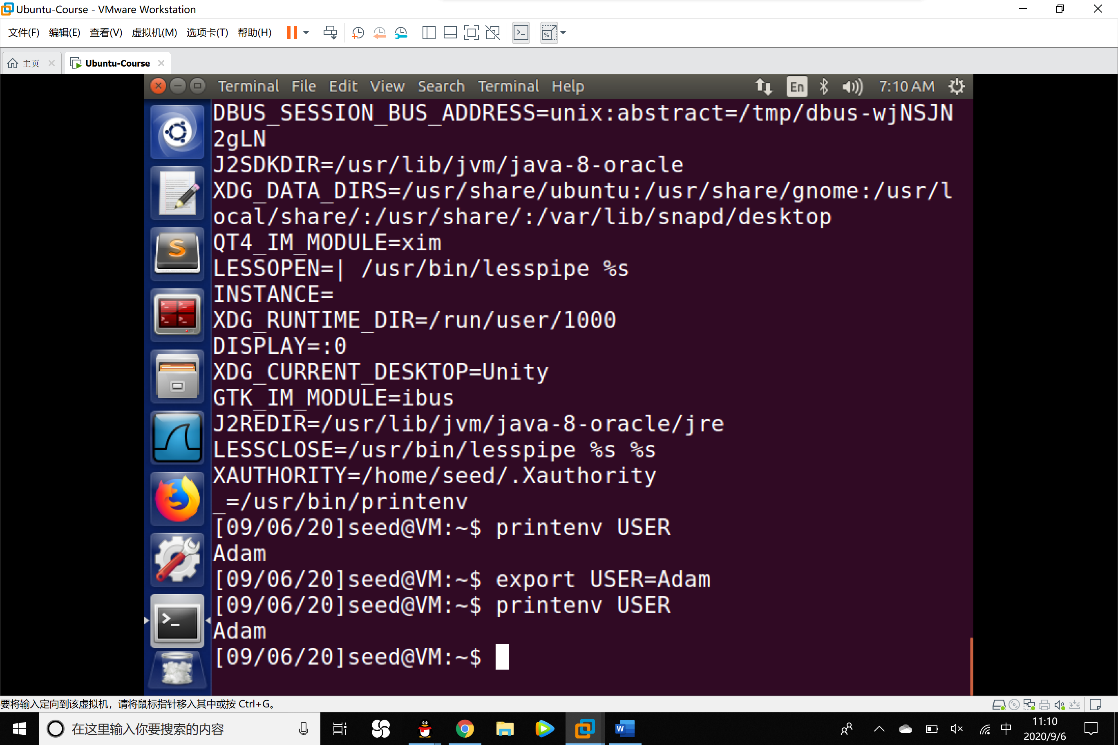

Task 2: Passing Environment Variables from Parent Process to Child Process

1. Compile and run the following program, and describe your observation. Save the output into a file.
2. #include <stdio.h>
3. #include <stdlib.h>
5. **extern** **char** **environ;
7. **void** printenv()
8. {
9. **int** i=0;
10. **while**(environ[i]!=NULL)
11. {
12. printf("%s\n",environ[i]);
13. i++;
14. }
15. }
17. **void** main()
18. {
19. pid_t childPid;
21. **switch**(childPid=fork())
22. {
23. **case** 0: /*child process*/
24. printenv();
25. exit(0);
26. **default**: /*parent process*/
27. //printenv();
28. exit(0);
29. }
30. }

Observation: The Environments Variables of the child process are printed and saved in to a file named child1.txt.

1. Comment out the printenv() statement in the child process case, and uncomment the printenv() statement in the parent process case. Compile and run the code again, and describe your observation. Save the output in another file.

Observation: The Environment Variables of the parent process are printed and saved into a file named child2.txt. It seems that the outcome is the same as the child process’s.

1. Compare the difference of these two files using the diff command. Please draw your conclusion.

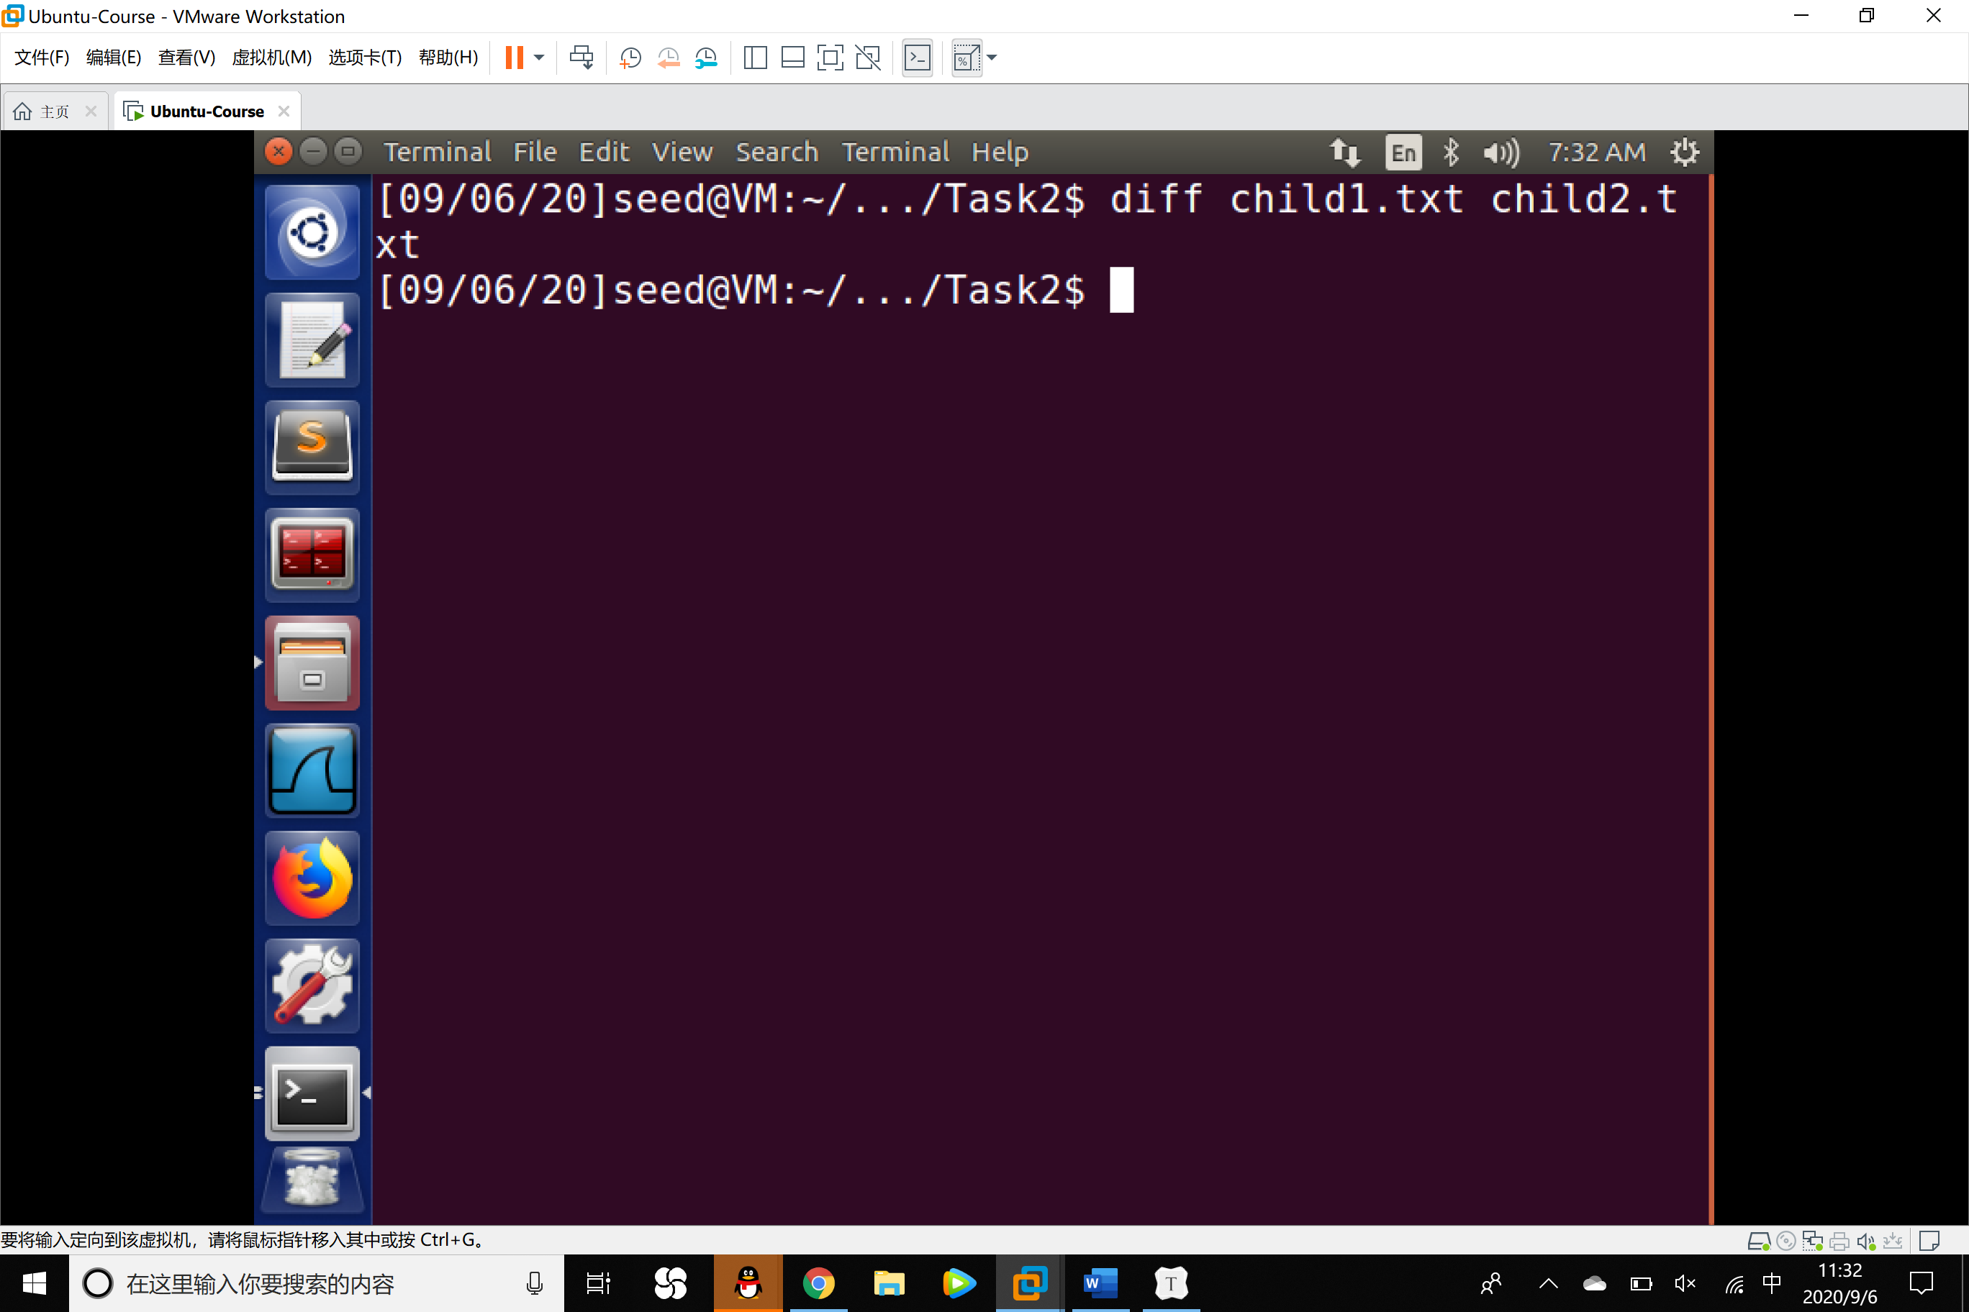

Conclusion: After commanding the diff command, no outcome was shown. It means environment variables of the parent process are inherited by the child process.

Task 3: Environment Variables and execve()

1. Compile and run the following program, and describe your observation. This program simply executes a program called /usr/bin/env, which prints out the environment variables of the current process.
2. #include<stdio.h>
3. #include<stdlib.h>
5. **extern** **char** **environ;
7. **int** main()
8. {
9. **char** *argv[2];
11. argv[0]="usr/bin/env";
12. argv[1]=NULL;
14. execve("/usr/bin/env",argv,NULL);
16. **return** 0;
17. }

Observation: When executing the program which prints the environment variables, no output was shown.

1. Change the invocation of execve() in line 13 to the following; describe your observation.

execve("/usr/bin/env",argv,environ);

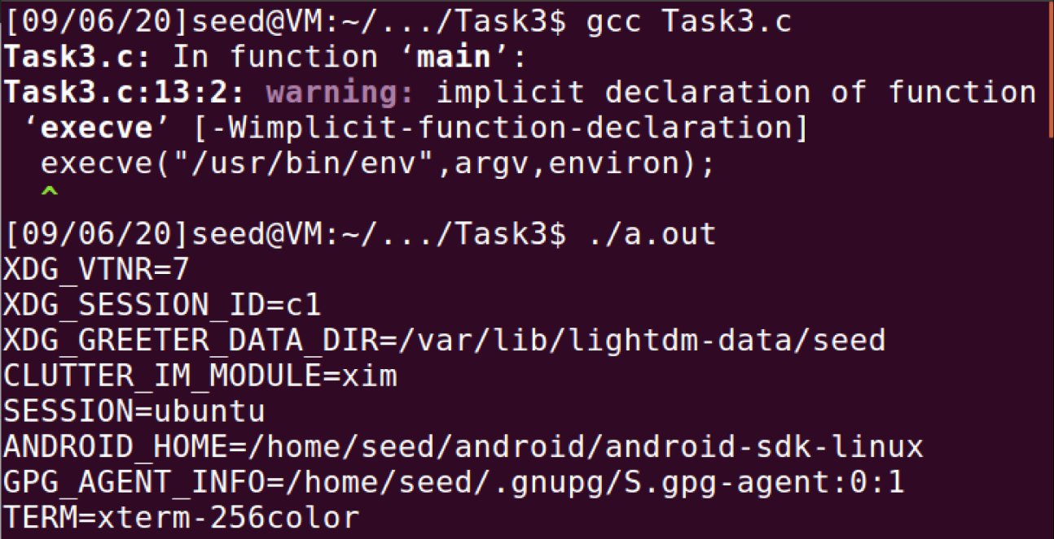

Observation: The environment variables are printed.

1. Please draw your conclusion regarding how the new program gets its environment variables.

Conclusion: The new program gets its environment variables var the third parameter of the function execve(). When we pass the environ to the function, the new program gets its environment variables.

Task 4: Environment Variables and system()

In the implementation of the system() function, you will see that it uses execl() to execute /bin/sh; execl() calls execve(), passing to it the environment variables array. Therefore, using system(), the environment variables of the calling process is passed to the new program /bin/sh.

Please compile and run the following program to verify this.

1. #include <stdlib.h>
2. #include <stdio.h>
4. **int** main()
5. {
6. system("/usr/bin/env");
7. **return** 0;
8. }

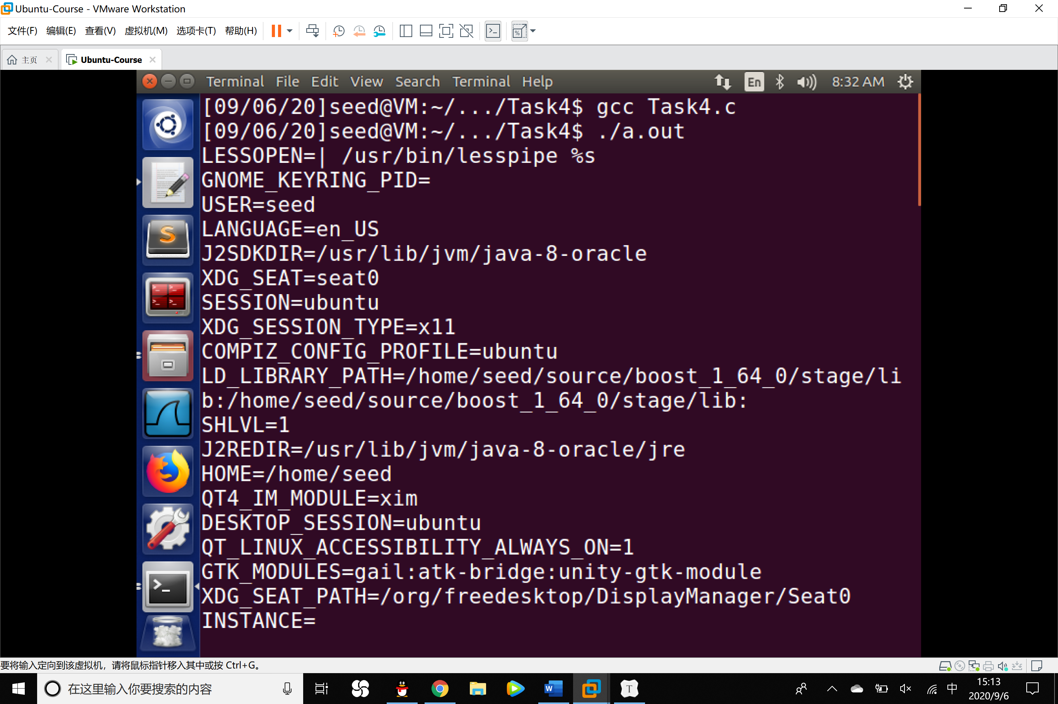

Conclusion：After executing the program, the environment variables of the current process were printed at the terminal, which is exactly the same as what we witnessed in Task3. This outcome can verify that the function execve() was called and the program called /usr/bin/env was executed, which satisfied the implementation details of the function system().

Task 5: Environment Variable and Set-UID Programs

1. Write the following program that can print out all the environment variables in the current process.
2. #include <stdio.h>
3. #include <stdlib.h>
5. **extern** **char** **environ;
7. **void** main()
8. {
9. **int** i=0;
10. **while** (environ[i]!=NULL)
11. {
12. printf("%s\n",environ[i]);
13. i++;
14. }
15. }
16. Compile the above program, change its ownership to root, and make it a Set-UID program.
17. //Assume the program's name is foo
18. $ sudo chown root foo
19. $ sudo chmod 4755 foo

3. In your shell, use the export command to set the following environment variables(they may have already exist):

PATH

LD_LIBRARY_PATH

ANY_NAME (this is an environment variable defined by you, so pick whatever name you want).

These environment variables are set in the user’s shell process. Run the Set-UID program from Step 2 in the shell. Check whether all the environment variables you set in the shell process(parent) get into the Set-UID child process. Describe your observation. If there are surprises to you, describe them.

Answer:After resetting the referred environment variables:

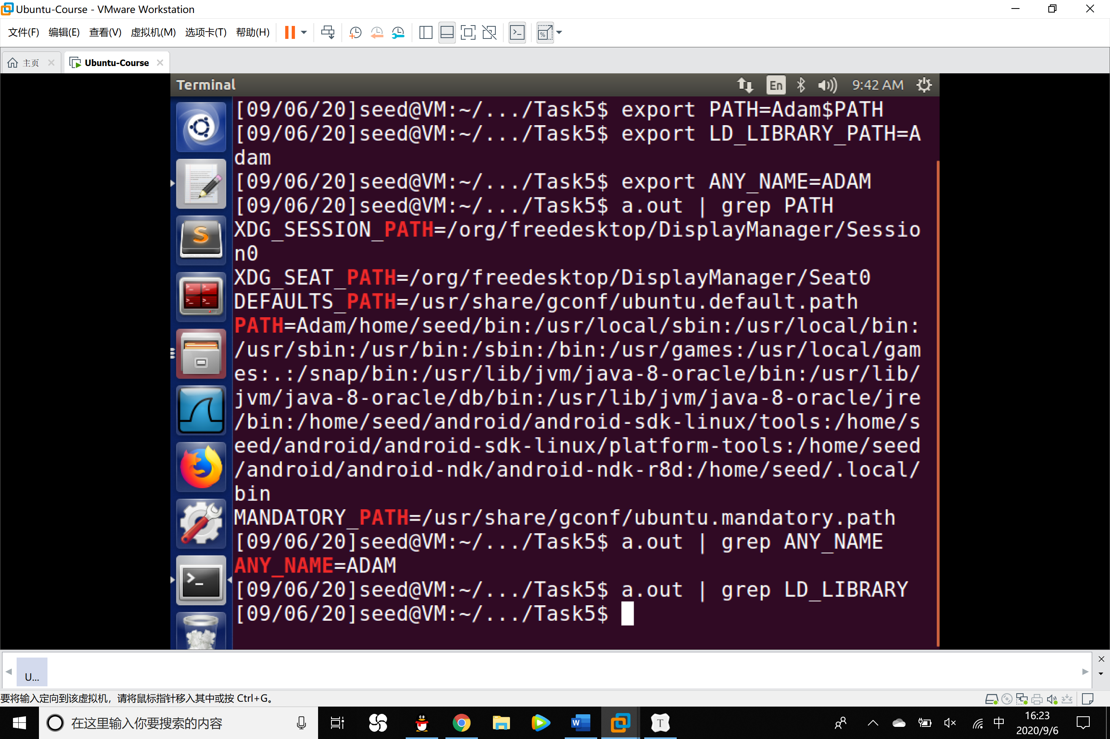

In the Set-UID child process, PATH and ANY_NAME have been reset and passed in, while the environment variable LD_LIBRARY_PATH can **not** be found, it wasn’t passed into the child process.

Task 6: The PATH Environment Variable and Set-UID Programs

1. **int** main()
2. {
3. system("ls");
4. **return** 0;
5. }

Compile the above program, and change its owner to root, and make it a Set-UID program. Can you let this Set-UID program run your code instead of /bin/ls? If you can, is your code running with the root privilege? Describe and explain your observations.

Answer:

1. #include <stdio.h>
3. **int** main()
4. {
5. **if** (getuid() != 0)
6. {
7. printf("This program is NOT running as root\n");
8. }
9. **else**
10. {
11. printf("This program is running as root\n");
12. }
13. }

If the Set-UID program can run my code, the terminal will show whether my code is runningwith the root privilege.

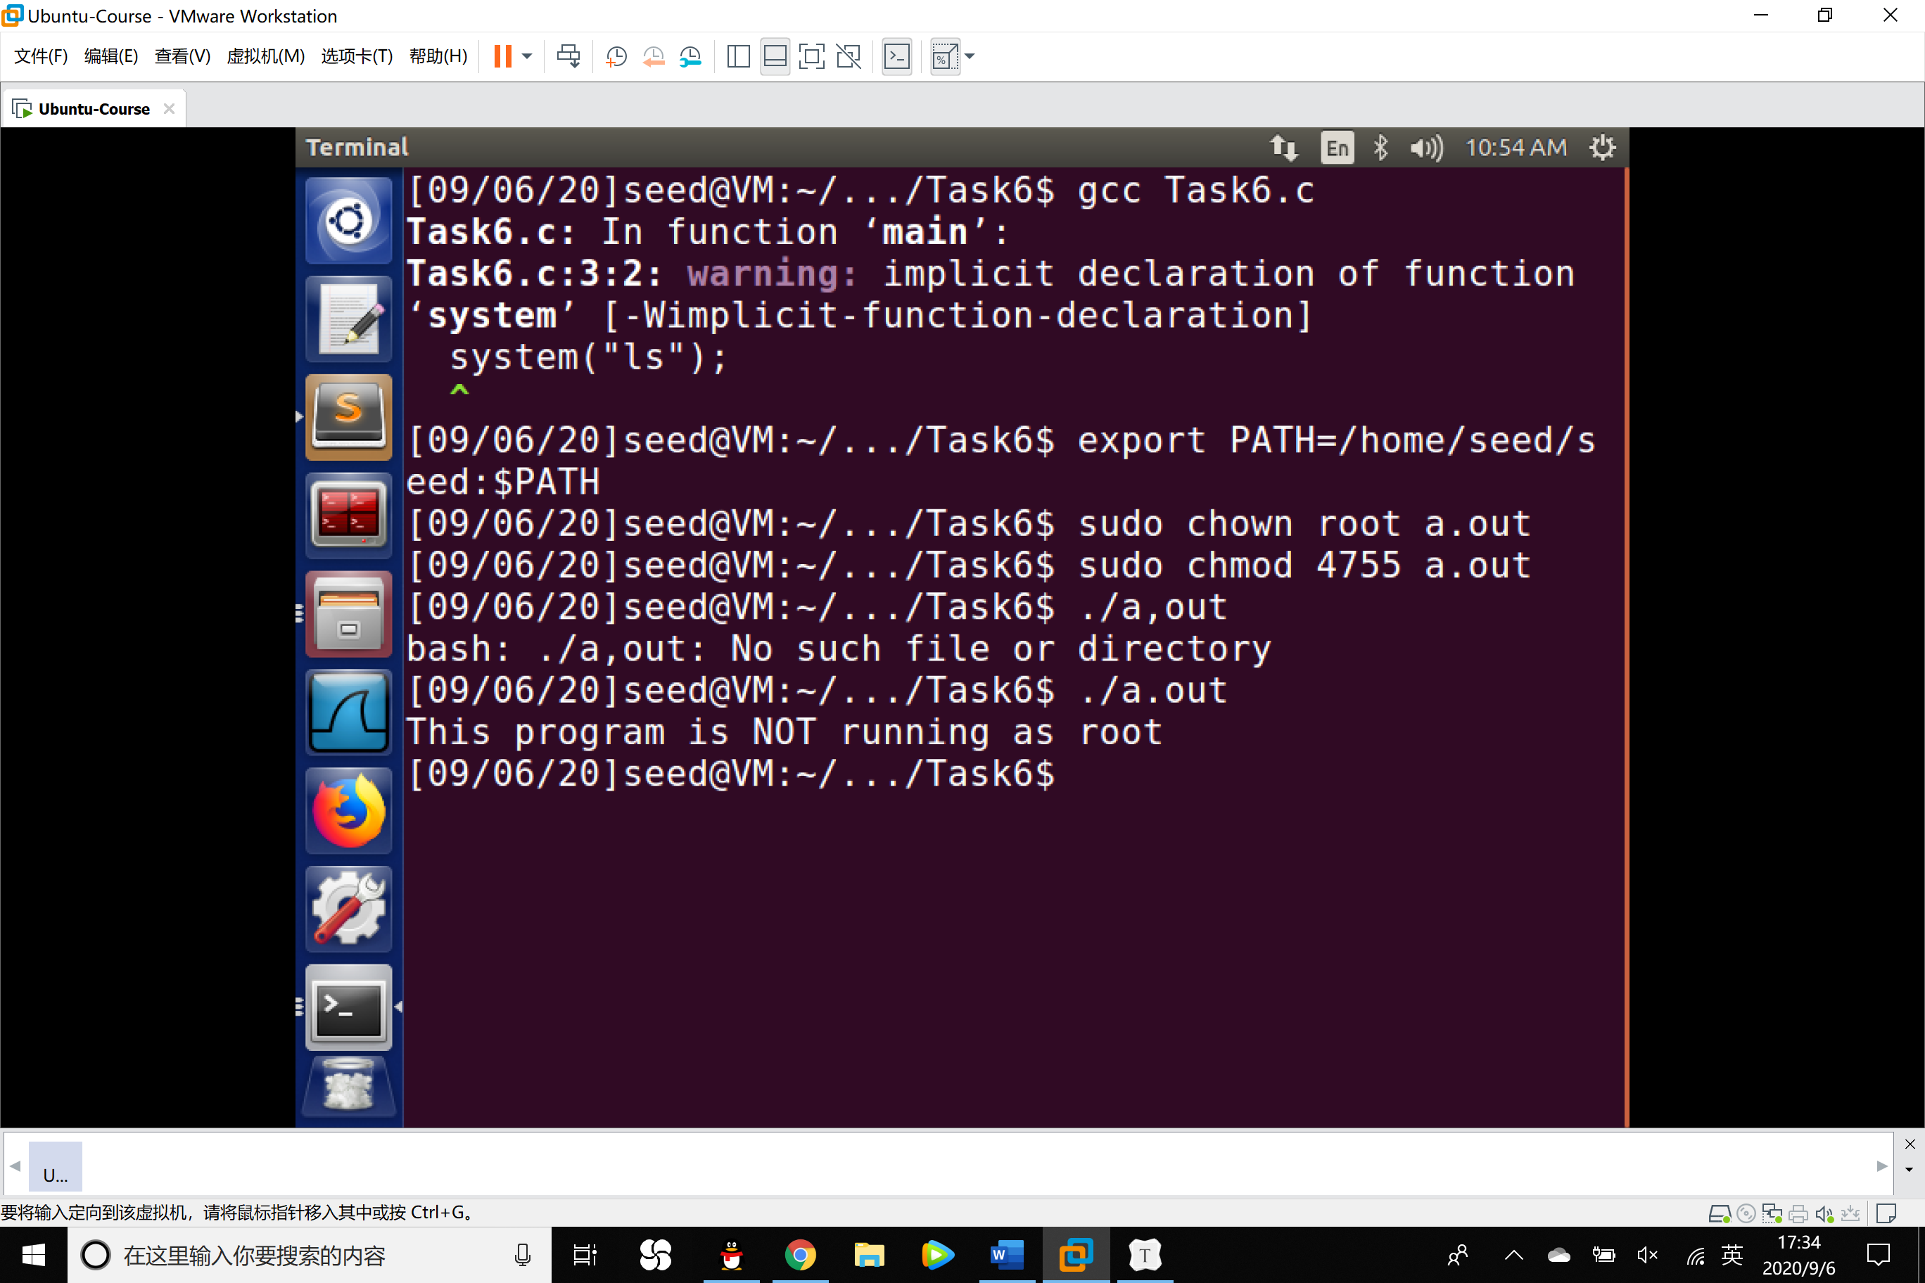

Conclusion:

By several operations, the Set-UID program can run the referred code instead of /bin/ls, meanwhile the code is not running in the root privilege. The explanation can be checked in the Note part. If dash detects that it is executed in a Set-UID process, it immediately changes the effective user ID to the process’s real user ID, essentially dropping the privilege.

After using the following command to link /bin/sh to zsh:

The privilege whie running our designed code can be kept at root:

1. $ sudo rm /bin/sh
2. $ sudo ln -s /bin/zsh /bin/sh

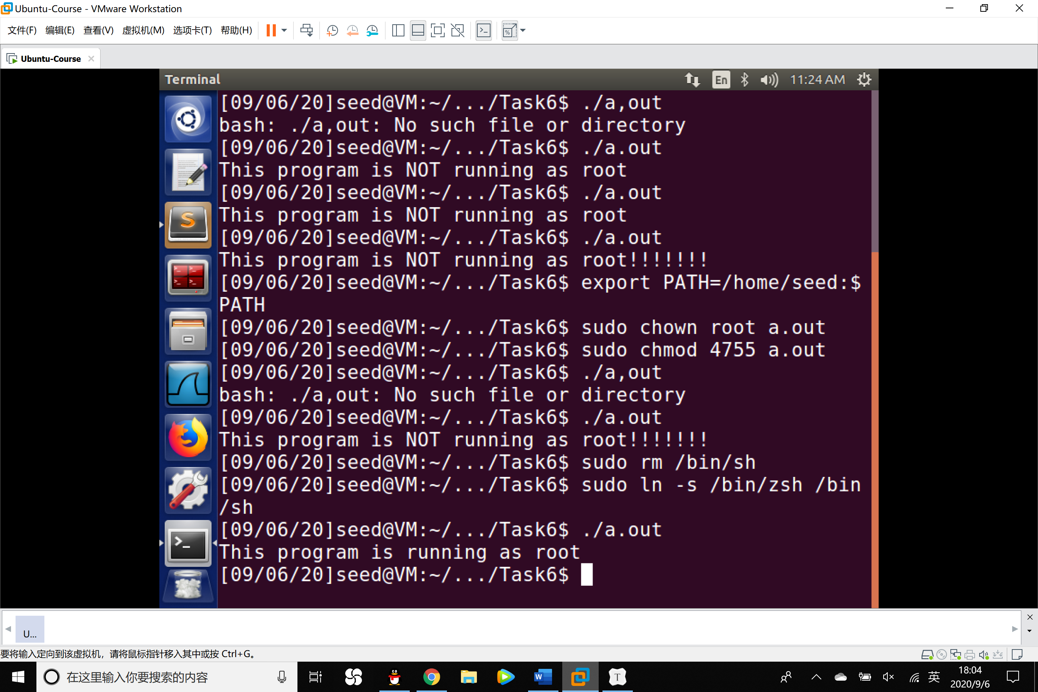

Task 7: The LD_PRELOAD Environment Variable and Set-UID Programs

1. Build a dynamic link library. Create the following program and name it mylib.c.
2. #include <stdio.h>
3. **void** sleep(**int** s)
4. {
5. /*If this is invoked by a privileged program,
6. you can do damages here! */
7. printf("I am not sleeping!\n");
8. }
9. Compile the above program using commands:
10. % gcc -fPIC -g -c mylib.c
11. % gcc -shared -o libmylib.so.1.0.1 mylib.o -lc

3. Set the LD_PRELOAD environment variable:

%export LD_PRELOAD=./libmylib.so.1.0.1

4. Compile the following program myprog, and in the same directory as the above dynamic link library libmylib.so.1.0.1:

1. /*myprog.c*/
2. **int** main()
3. {
4. sleep(1);
5. **return** 0;
6. }

5. Run myprog under the following conditions, and observe what happens.

● Make myprog a regular program, and run it as a normal user.

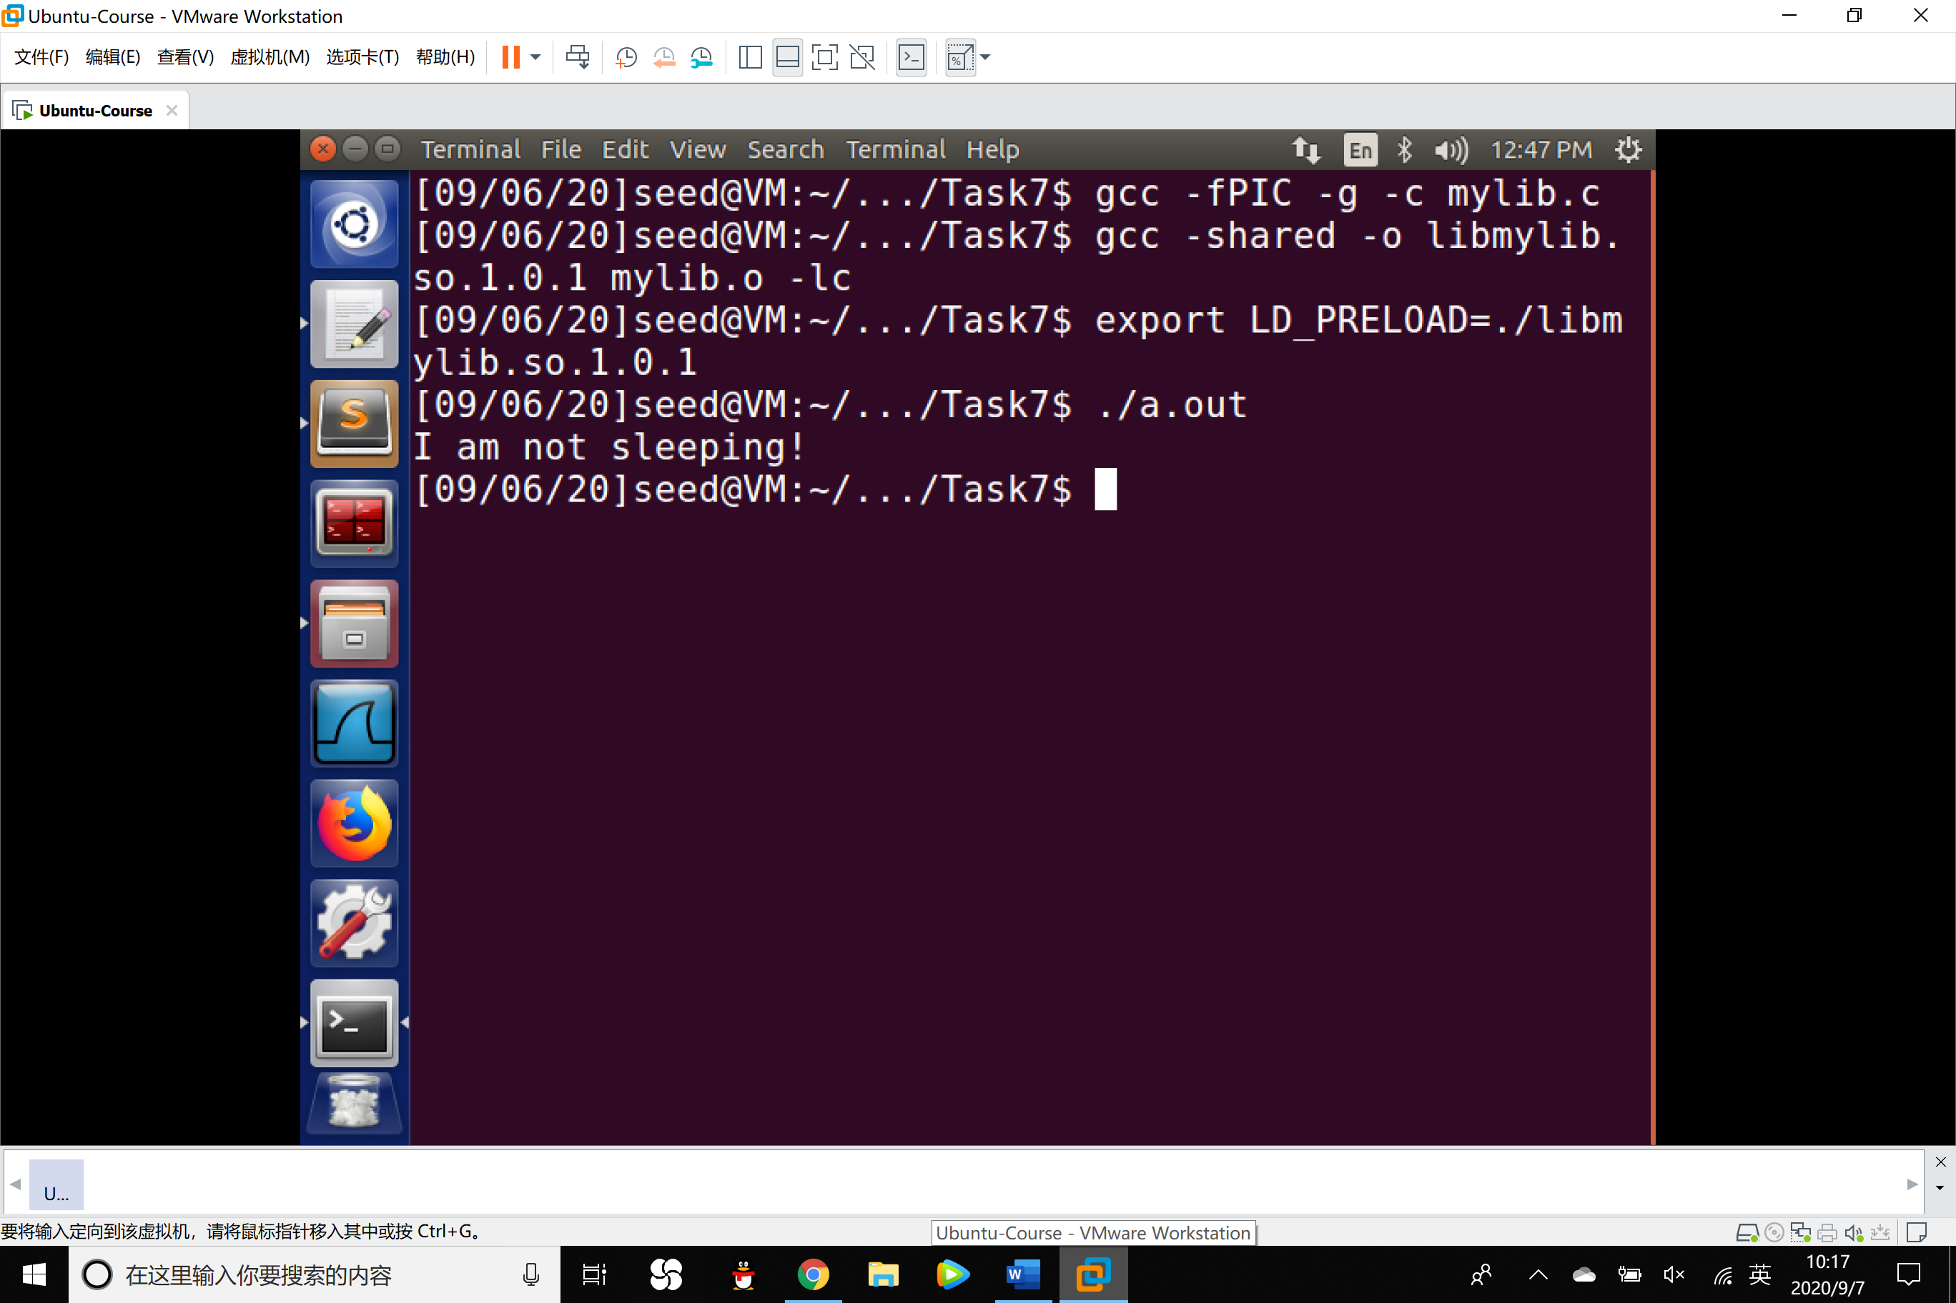

(The sleep() function we make has been executed)

● Make myprog a Set-UID program, and run it as a normal user.

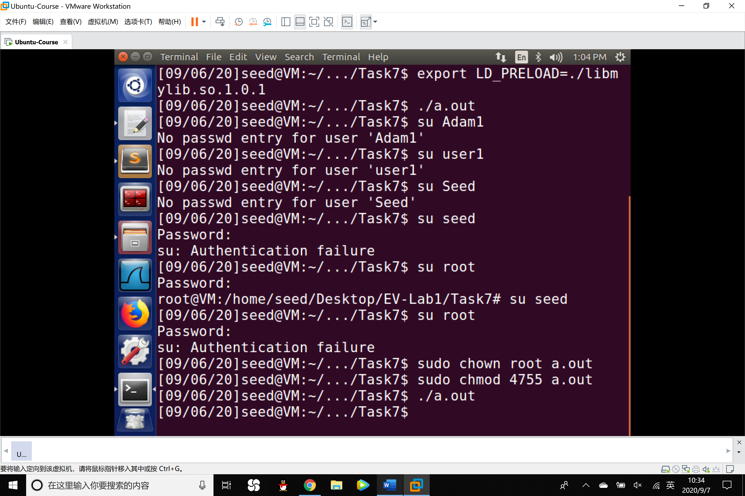

(The sleep() function in libc has been executed)

● Make myprog a Set-UID program, export the LD_PRELOAD environment variable again in the root account and run it.

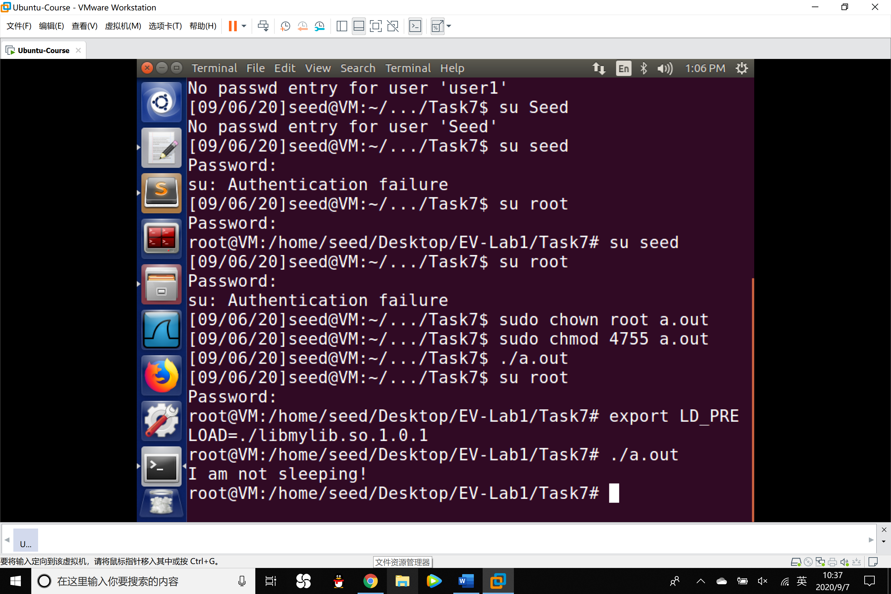

● Make myprog a Set-UID user1 program, export the LD_PRELOAD environment again in different user’s account (not root user) and run it.

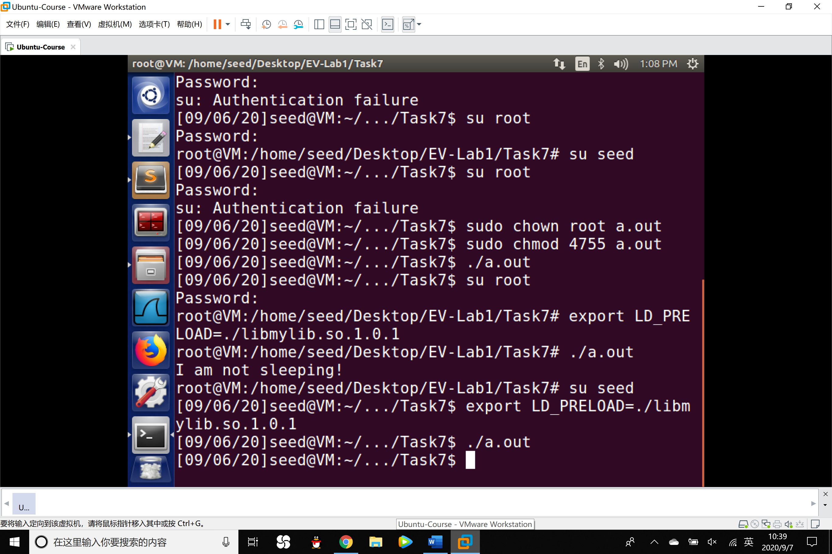

6. Figure out what causes the difference. Environment variables play a role here. Please design an experiment to figure out the main causes, and explain why the behaviors in different conditions are different.

Experiment Design: It is possible that when we set a normal program to a root Set-UID program, the child process of the Set-UID program does not inherit the LD_PRELOAD environment variables, this is an strategy for the concern of safety.

So we copy the program of /usr/bin/env which can print the environment variables and name it myenv. Make myenv a root Set-UID program and export the LD_PRELOAD. We use grep command to check whether the LD_PRELOAD has been inherited.

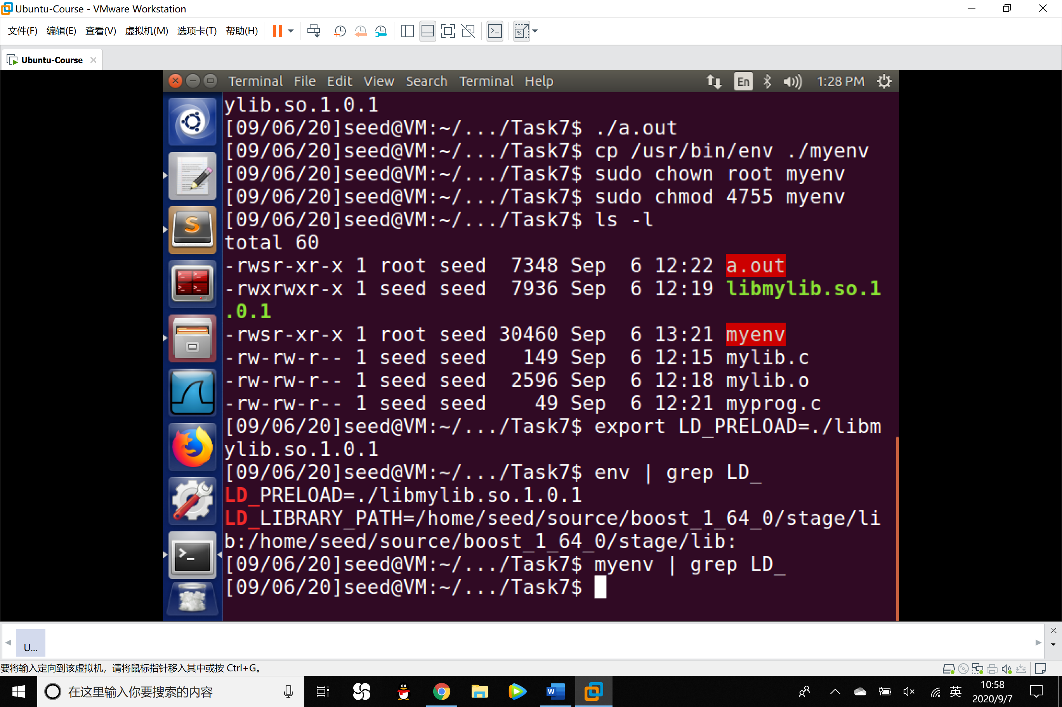

Conclusion: We can see that in the env program, the LD_PRELOAD has been modified while in the Set-UID myenv program, the LD_PRELOAD was not inherited when executed.

Task 8: Invoking External Programs Using system() versus execve()

1. #include <string.h>
2. #include <stdio.h>
3. #include <stdlib.h>
5. **int** main(**int** argc,**char** *argv[])
6. {
7. **char** *v[3];
8. **char** *command;
10. **if**(argc<2)
11. {
12. printf("Please type a file name.\n");
13. **return** 1;
14. }
16. v[0]="/bin/cat";
17. v[1]=argv[1];
18. v[2]=NULL;
20. command=malloc(strlen(v[0])+strlen(v[1])+2);
21. sprintf(command,"%s %s",v[0],v[1]);
23. //Use only one of the followings.
24. system(command);
25. //execve(v[0],v,NULL);
27. **return** 0;
28. }

Compile the above program, make it a root-owned Set-UID program. The program will use system() to invoke the command. If you were Bob, can you compromise the integrity of the system? For example, can you remove a file that is not writable to you?

Answer: Bob can remove the file that is originally not writable.

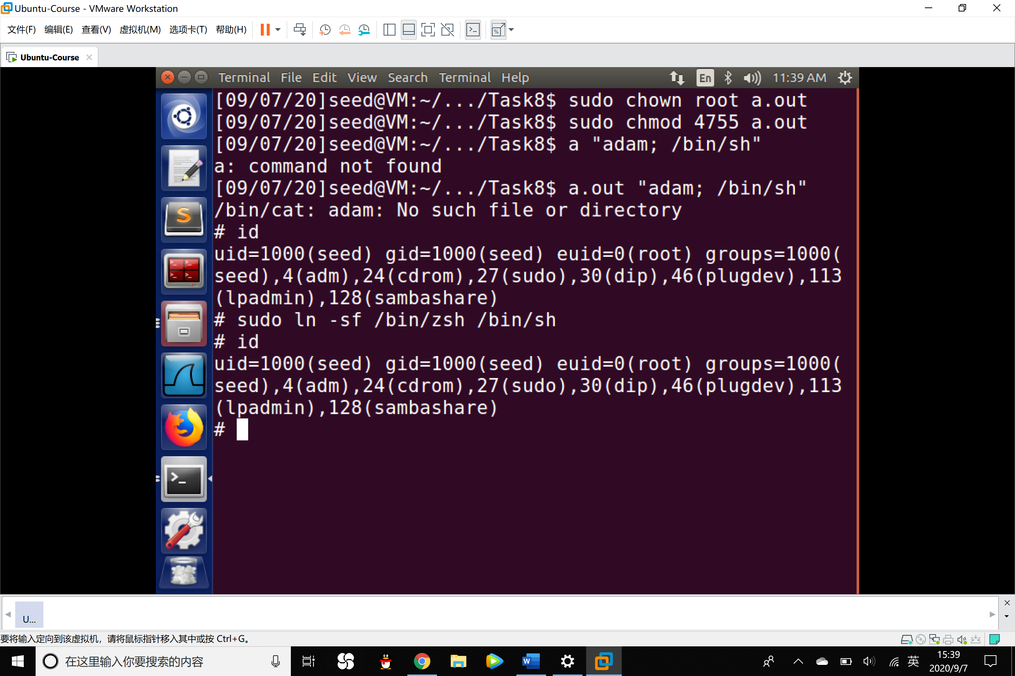

By using the command : a.out ”adam; /bin/sh”, in the second command, the Set-UID program will execute a shell program, so that Bob can get the root shell. From the # character and the euid=0, we can know that Bob gets the root shell so that he can remove a file that is not writable to him.

2. Comment out the system(command) statement, and uncomment the execve() statement; the program will use execve() to invoke the command. Compile the program, and make it a root-owned Set-UID. Do your attacks in Step 1 still work? Please describe and explain your observations.

Answer: The attack does not work right now.

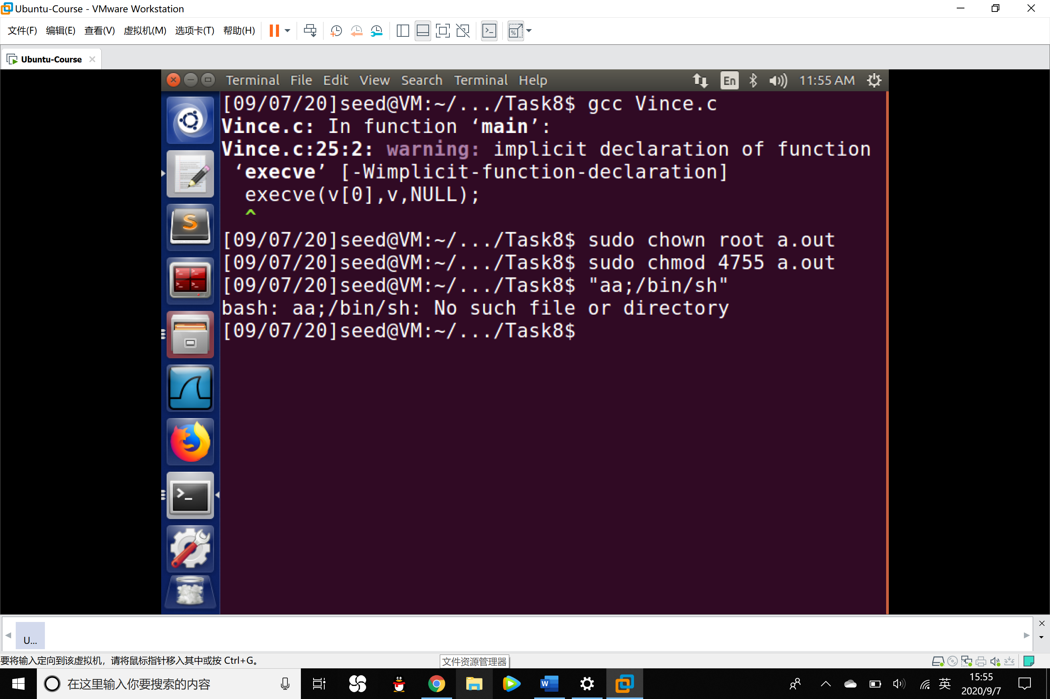

Explanation: Different from function system(), when executing, execve() ask for operating system to execute the command but not shell program so that the /bin/sh will be considered as part of the parameter but not a command, so that it ensures the safety of the whole system.

Task 9: Capability Leaking

Compile the following program, change its owner to root, and make it a Set-UID program. Run the program as a normal user, and describe what you have observed. Will the file /etc/zzz be modified? Please explain your explanation.

1. #include <stdio.h>
2. #include <stdlib.h>
3. #include <fcntl.h>
4. **void** main()
5. { **int** fd;
6. /* Assume that /etc/zzz is an important system file,
7. * and it is owned by root with permission 0644.
8. * Before running this program, you should creat
9. * the file /etc/zzz first. */
10. fd = open("/etc/zzz", O_RDWR | O_APPEND);
11. **if** (fd == -1) {
12. printf("Cannot open /etc/zzz\n");
13. exit(0);
14. }
15. /* Simulate the tasks conducted by the program */
16. sleep(1);
17. /* After the task, the root privileges are no longer needed,
18. it’s time to relinquish the root privileges permanently. */
19. setuid(getuid()); /* getuid() returns the real uid */
20. **if** (fork()) { /* In the parent process */
21. close (fd);
22. exit(0);
23. } **else** { /* in the child process */
24. /* Now, assume that the child process is compromised, malicious
25. attackers have injected the following statements
26. into this process */
27. write (fd, "Malicious Data\n", 15);
28. close (fd);
29. }
30. }

Observation:

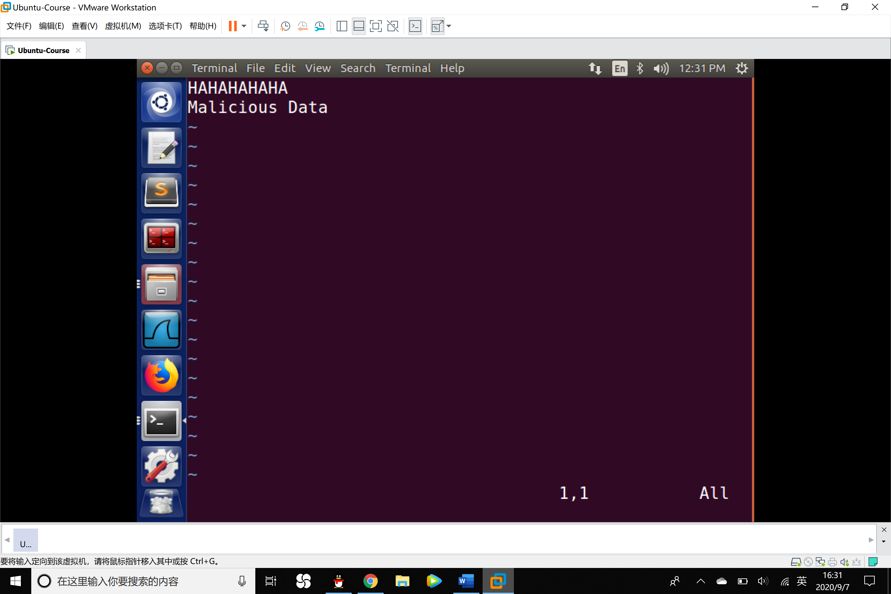

The malicious data has been injected into the file.

Conclusion: It is because when the privilege is downgraded, the program does not clean up the capability of reading and modifying the file so that the capability is still accessible by the non-privileged process. In other words, although the effective user ID of the process becomes non-privilege, the process is still privileged because it possesses privileged capabilities.